Under Construction
Design a scaled down model (1:50) of a flyover connecting two platforms of height 10m (20cm) and 15m (30cm) and going over a overhead tram network midway of the flyover span of height 15m (30cm), using only straws, satisfying the understated constraints and that can withstand a moving load passing the flyover.
Download PDF

Eligibility
All students with a valid identity card of their respective institutes are eligible to participate in Overcrawl at Techfest 2005.

Team Size
A team can consist of a maximum of two students.

Plot Specifications
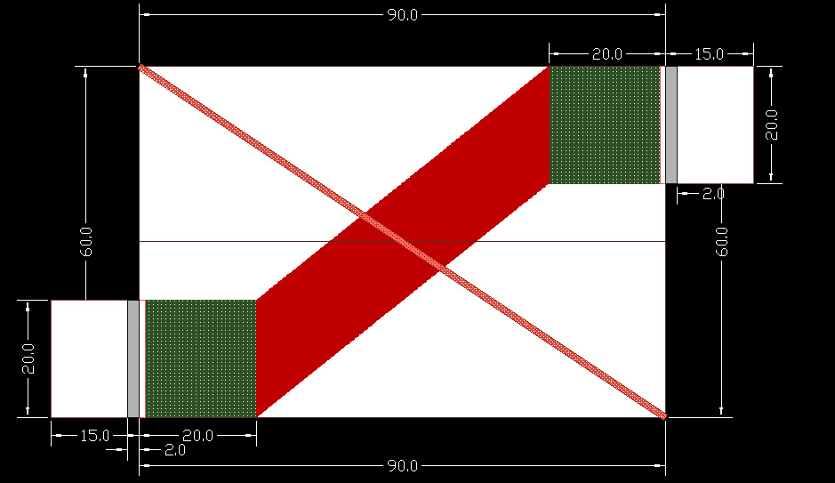
There are platforms of height 20cm and 30cm on which the ends of the flyover will rest at two diagonally opposite ends, A and B respectively, of a 60cm*90cm base platform.
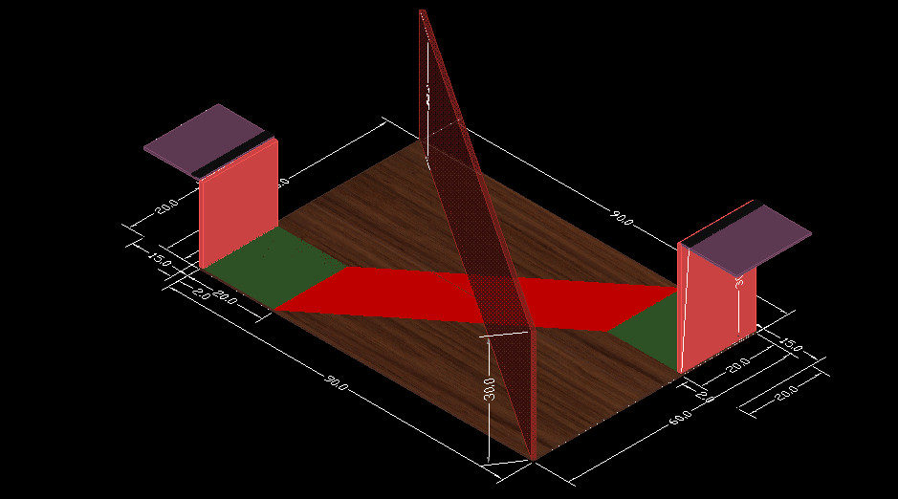 | 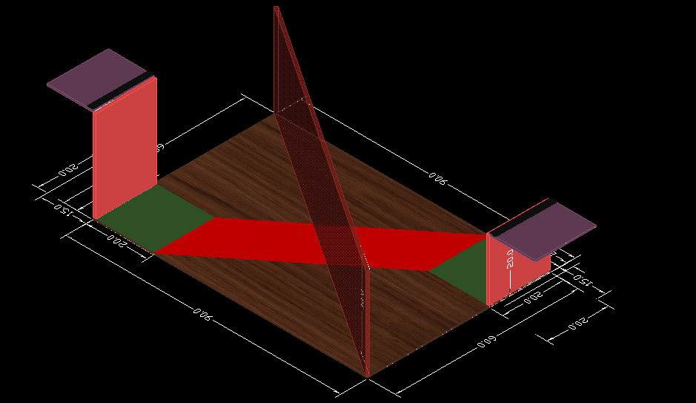
The green zone in front of the 20cm and 30cm high platforms are squares of 20cm. The flyover can have supports from ground in the form of pillars etc in this zone.
The red zone joining the edges of the two green squares is the restricted zone. No part of your flyover shall have any support in the red zone or even touch the red zone.
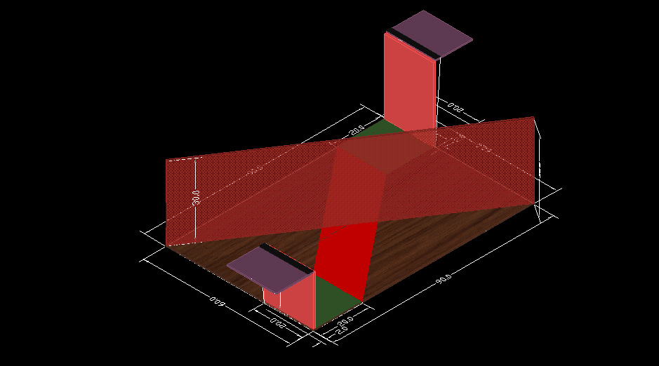
A diagonal obstacle of height 30cm joins ends B and D (see top view).
^ TOP

Design Constraints
- The plot is a 90cm*60cm rectangle with two platforms at diagonally opposite ends A and B of height 20 cm and 30 cm respectively.
- The ends of the flyover will be placed on 20cm and 30cm high platforms at ends A and B. The length of the flyover should be such that the ends should rest on these platforms where it will be clamped to the purple platform. The structure should have at least two straws of minimum length 2 cm provided at the end of the structure which will be used for clamping the structure to the platform. The clamping mechanism will be provided on this platform in the black zone of width 2 cm as shown in the fig.
- The deck of the flyover should be at least 20 cm wide and maximum 30 cm wide.
- Flyover must clear the 30 cm obstacle placed diagonally joining points B and D before the testing starts. At no point of time any part of the flyover shall touch this 30 cm high obstacle.
- Green Zone: The two Green zones are squares of 20cm as shown in the fig. The flyover can be provided support using pillars etc in this zone. Flyover can have supports from ground of any dimension and of any kind in the green zones.
- Red Zone: The red zone joining the facing edges of the two green zones as shown in the fig. is the restricted zone. Supports can not be provided in this zone. No part of the flyover shall touch ground in this zone. A clearance of 15 cm has to be provided in the red zone such that an object 15 cm high can traverse the red zone without touching any part of the flyover.
- Pillars can be provided to support the flyover at all the places except the Red zone.
- Pillars will not be fixed on the ground and has to rest on its own. The max dimension of any pillar�s base touching the ground anywhere other than the Green zone shall not exceed 7.5cm*7.5cm.
^ TOP

Materials to be used
- Straws (provided by us after registration)
- Standard pins
- Any standard adhesive (e.g. Quickfix or fevicol etc.) can be used to join the straws and must not be applied to any part other than joints. Tape or thread must not be used under any circumstances to support the structure.
- A cardboard of the shape of the deck of the flyover. This cardboard must fit into the deck through which the moving load will pass. The cardboard has to cover the deck well so that the trolley containing the load can move over the flyover deck, failing which the structure will be assumed to have failed.
^ TOP

Materials Constraints
- Joints and overlaps - maximum overlaps between the ends of the straws at the joints shall not exceed 2cm under any circumstances.
- There should not be any cuts along the length of the straws and no holes in between the length of the straws except by those made by pins. Cutting straws along the length is not allowed.
- Bending of straws in any way is not allowed, after the bearing of load the straws may bend but the structure which is submitted should have all straight straws.
^ TOP

General Rules
- Shape - Flyover could be of absolutely any shape satisfying the above constraints.
- Once the flyover is weighed, you are not allowed to modify your structure in any way.
- If the flyover fails to satisfy any of the above constraints then it will be summarily rejected.
- Once the structure is clamped, participants are not allowed to touch it and no changes are allowed to be made in any case.
^ TOP

Definition of Failure
The flyover will be assumed to have failed if anything of the following happens:
- Flyover fails to satisfy any of the constraints specified above.
- Flyover touches the 30cm high obstacle placed diagonally midway of the plot.
- Any part of the flyover touches the red zone on the ground at any point of time during the course of testing.
- Flyover actually fails and is not in a condition to carry the moving load over its deck.
^ TOP

Winning Criteria
The winning criteria would be the ratio of load resisted before the flyover fails to the self load of the structure. The flyover which ends up with the maximum ratio of load resisted before failing to the self load of the structure will be declared winner.
^ TOP

Registration and Important dates
- Each team has to register online. A registration number will be allocated to the team on registration which shall be used for future reference.
- Last date of registration for outstation teams is 31st December 2004.
All changes that will be made in the problem statement at any later stage shall be intimated to the participants through e-mail and indicated on the webpage in RED. Please keep yourself updated regularly.
In case of any query contact
Saurabh Kumar
Manager, Last Straw
Techfest 2005
Email: saurabh@techfest.org

